Project Design Phase
Solution Architecture

Date | 12 July 2026
Team ID | PNT2026TMID_OPTICROP
Project Name | OptiCrop - Smart Agricultural Production Optimization Engine
Maximum Marks | 4 Marks

Solution Architecture:
Solution architecture is a complex process – with many sub-processes – that bridges the gap between business problems and technology solutions. Its goals are to:
- Find the best tech solution to solve existing business problems.
- Describe the structure, characteristics, behavior, and other aspects of the software to project stakeholders.
- Define features, development phases, and solution requirements.
- Provide specifications according to which the solution is defined, managed, and delivered.

Example - Solution Architecture Diagram:


Figure 1: Architecture and data flow of the voice patient diary sample application
Reference: https://aws.amazon.com/blogs/industries/voice-applications-in-clinical-research-powered-by-ai-on-aws-part-1-architecture-and-design-considerations/

Our Solution Architecture — OptiCrop
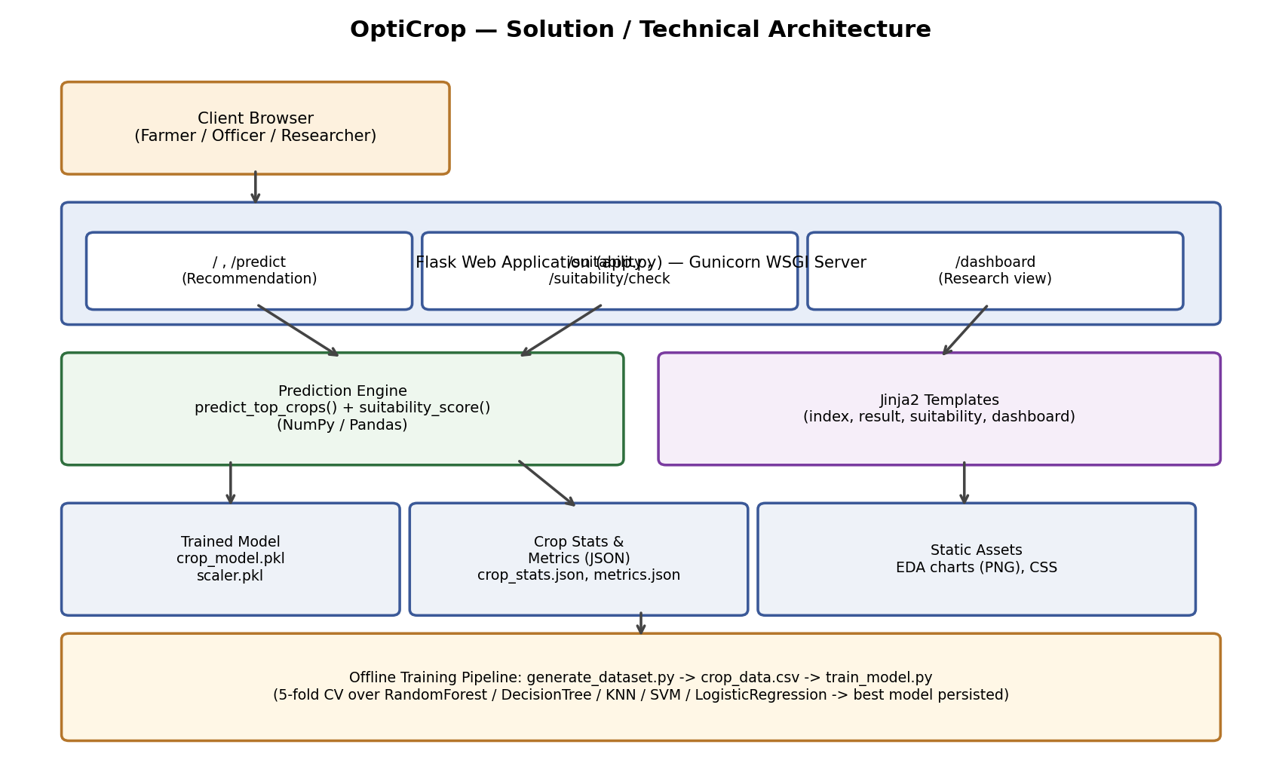

Architecture Description
• Client Layer: any browser submits soil/climate values through simple HTML forms (index, suitability pages).
• Application Layer: a single Flask app (app.py), served by Gunicorn in production, exposes 5 routes covering the 3 scenarios — recommendation, suitability check, and dashboard.
• Logic Layer: predict_top_crops() scales inputs with the persisted StandardScaler and calls the trained classifier's predict_proba for a ranked top-3; suitability_score() computes a Gaussian match score per feature against each crop's stored mean/std.
• Presentation Layer: Jinja2 templates render results server-side — no separate frontend framework/build step is required.
• Data / Artifact Layer: crop_model.pkl, scaler.pkl, crop_stats.json and metrics.json are generated once by the offline training pipeline and loaded into memory at app startup for fast, stateless inference.
• Offline Pipeline: generate_dataset.py synthesizes the 22-crop agronomic dataset; train_model.py runs EDA, trains & 5-fold cross-validates 5 classifiers, and persists the best-performing model (SVM, ~95.8% accuracy) along with evaluation charts.

